**Task 2: EV Market Segmentation**

-By Rishabh Hanselia

**Customer Sentiment for 2-Wheeler EVs**

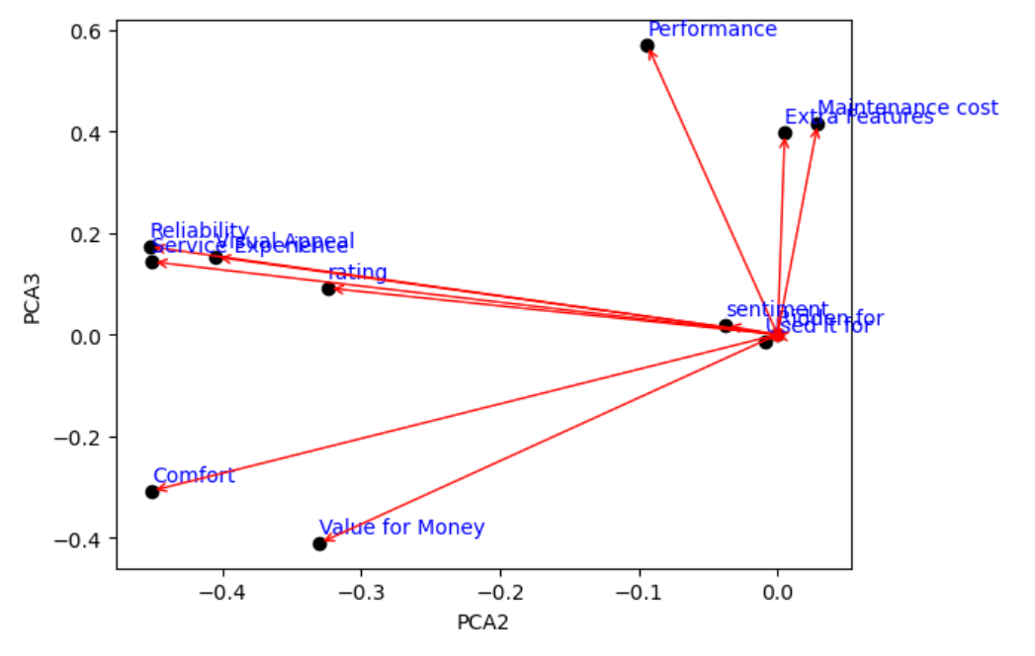

Positive Correlations: Reliability, service experience, rating, and visual appeal are all positively correlated. Cars scoring high in these areas tend to have higher overall sentiment scores.

Performance and extra features are positively correlated with maintenance cost. Cars with high performance and features are expected to have higher maintenance costs.

Comfort and value for money are positively correlated. People who find a car comfortable are more likely to believe it offers good value for money.

Value for Money: This factor seems to be negatively correlated with performance, reliability, and comfort. This suggests that customers who find a 2-wheeler EV to be good value for money may be willing to sacrifice some performance, reliability, or comfort.

**Customer Sentiment for 4-Wheeler EVs**

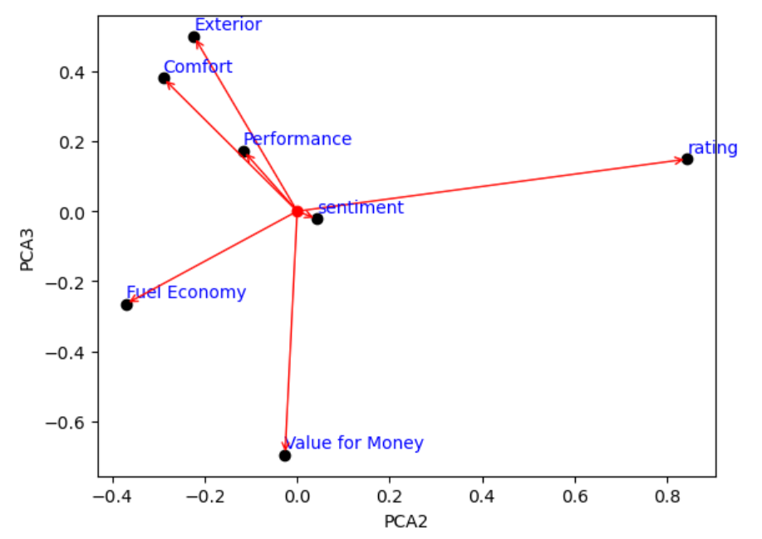

Positive Correlation:

Exterior: This appears to be positively correlated with Comfort. Customers who find the exterior of a four-wheeler EV appealing tend to also rate it as comfortable.

Negative Correlation:

Performance: This appears to be negatively correlated with Fuel Economy and Value for Money. This suggests that customers who prioritize performance in a four-wheeler EV may be willing to sacrifice fuel efficiency and affordability.

Comfort: This appears to be negatively correlated with Value for Money. Customers who find a four-wheeler EV to be comfortable may be willing to pay a higher price for it.

**EV Units by States**

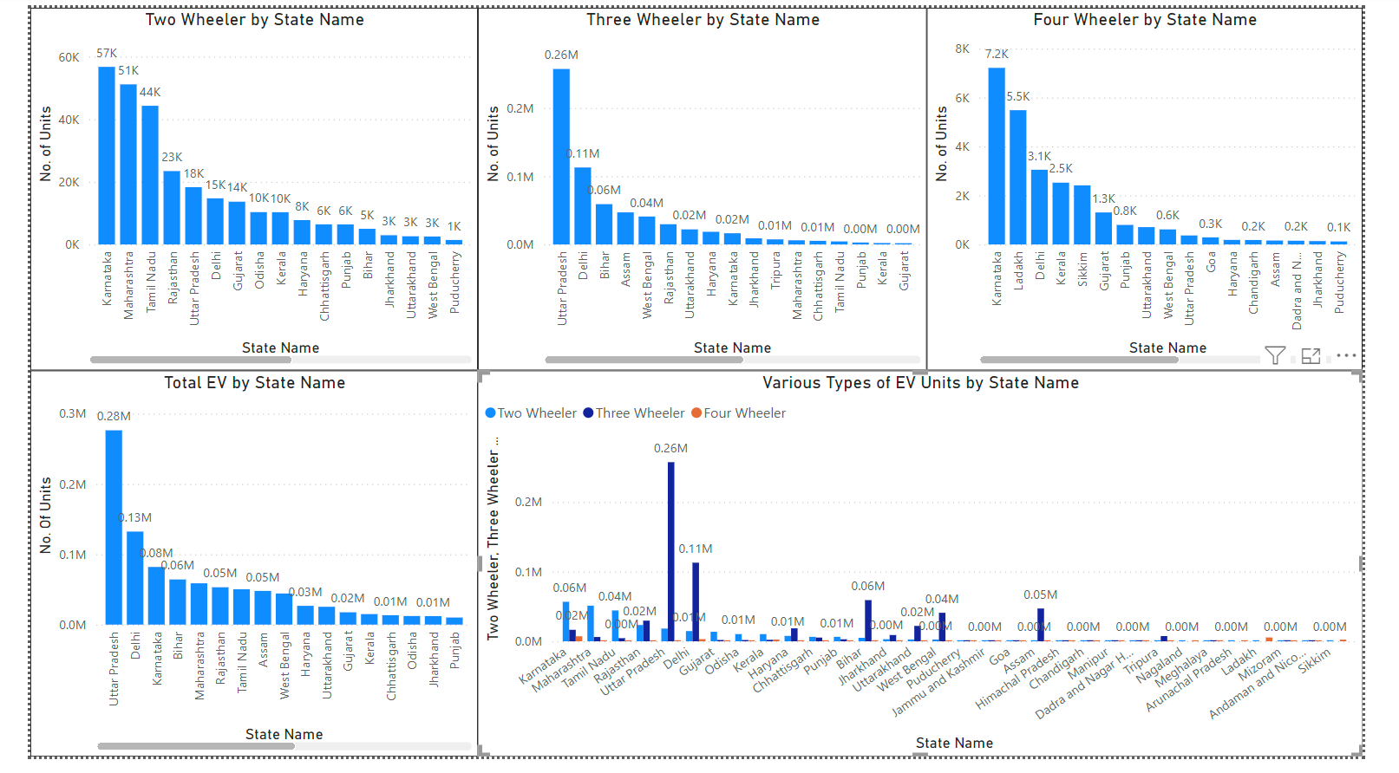

State Level Segmentation:

Top States: Uttar Pradesh, Karnataka, Maharashtra, and Tamil Nadu appear to have the highest numbers of EV units across categories (Two Wheeler, Three Wheeler, Four Wheeler). These states could be prioritized for EV market development and infrastructure investment.

Other Potential States: States like Gujarat, Andhra Pradesh, and Haryana are also showing promise with a decent number of EV units. These states could be potential targets for future expansion.

Lower Penetration States: States with a significantly lower number of EV units across categories might require targeted incentives or marketing campaigns to promote EV adoption.

Vehicle Type Segmentation:

Two-Wheeler Dominance: Two-wheeler EVs appear to have the highest numbers compared to Three Wheeler and Four Wheeler EVs across most states. This suggests a strong preference for two-wheeler EVs in the Indian market. Manufacturers and policymakers could focus on strategies to cater to this segment.

Three Wheeler and Four Wheeler Potential: Three-wheeler and Four-wheeler segments, though seemingly smaller, could hold potential for growth. Investigating the reasons behind the lower numbers in these segments could help identify barriers to adoption and inform targeted initiatives.

Public Service and Goods Vehicles:

The data shows a presence of Public Service and Goods Vehicles in the EV market. While the numbers appear relatively low, segmenting the market to understand the specific needs of these sectors could be beneficial for targeted infrastructure development and policy interventions.

Further Analysis:

Combining this data with additional information like population density, fuel prices, and public transportation infrastructure in each state could provide deeper insights into market segmentation.

Analyzing the reasons behind the low numbers in some states, especially for Three Wheeler and Four Wheeler segments, could help identify barriers to adoption and inform targeted initiatives.

**EV Charging Stations across India**

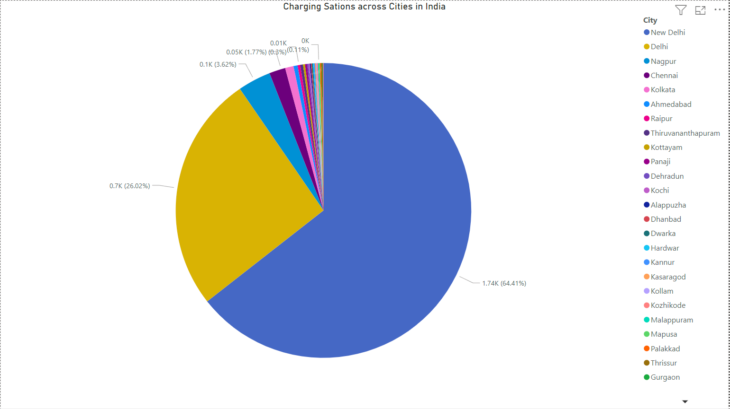

Geographic Segmentation:

* Focus Cities: Cities with a high number of charging stations, like New Delhi (1743), Delhi (704), Nagpur (98), Chennai (48), Kolkata (25) could be prioritized for EV market development due to the existing infrastructure. These cities likely have a higher concentration of early adopters and a more receptive market for EVs.
* Emerging Cities: Cities with a moderate number of charging stations (10-20) like Ahmedabad (12), Raipur (8), Thiruvananthapuram (8) could be potential targets for future expansion. These cities might be showing initial interest in EVs, and focusing on them could accelerate market growth.
* Lagging Cities: Cities with a low number of charging stations (less than 5) like Panaji (6), Kottayam (6), Kochi (4) might require significant infrastructure investment to encourage EV adoption. These cities may have lower initial interests in EVs, and targeted policies or incentives could be needed.

**EV Sales**

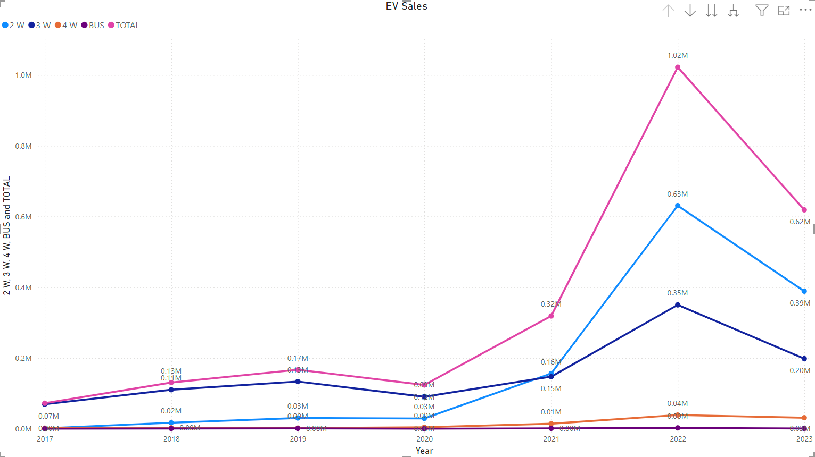

Time-Based Segmentation:

Growth Trend: There appears to be a general upward trend in EV sales across all categories (2 Wheeler, 3 Wheeler, 4 Wheeler, Bus) over the years, indicating a growing EV market in India. This suggests increasing awareness, adoption, and potentially government support for EVs.

Segment-wise Growth:

2-Wheelers: This segment appears to have the most consistent and significant growth throughout the period. This suggests a strong preference for electric two-wheelers in the Indian market, possibly due to factors like affordability, fuel efficiency, and maneuverability in traffic.

3-Wheelers: Three-wheeler sales show a growth trend but with some fluctuations. This segment could be promising, but further analysis might be needed to understand the reasons for the variations.

4-Wheelers: Four-wheeler sales show a gradual increase but appear to be at a lower volume compared to Two-wheelers and Three-wheelers. This suggests a slower adoption rate for electric four-wheelers, possibly due to higher price points or range limitations.

Buses: Bus sales are the least frequent but show an increasing trend. This segment has the potential for long-term environmental benefits, and government policies or subsidies could accelerate its growth.

Further Analysis:

By understanding these segmentation factors over time, policymakers and businesses can develop strategies to:

Promote EV adoption: Implement targeted incentives or marketing campaigns for different vehicle segments at the right time.

Expand charging infrastructure: Focus on areas experiencing significant EV growth to ensure adequate charging facilities.

Develop new EV models: Tailor features and pricing of new EV models to cater to the specific needs of each segment.

**Conclusions**

Vehicle Dominance: Two-wheelers lead due to affordability and maneuverability.

Emerging Segment: Three-wheelers show potential, but reasons behind sales variations need investigation.

Slower Adoption: Four-wheelers face price/range limitations but hold future growth potential.

Long-Term Opportunity: Public service/goods vehicles offer promise with targeted electrification initiatives.

Market Growth: Overall EV sales trend upwards, indicating a growing market in India.

Segment Growth: Two-wheelers show the most consistent and significant growth.

Three-wheeler & Four-wheeler Growth: Three-wheeler sales are increasing with fluctuations, while four-wheeler sales exhibit a gradual increase.

Electric Buses: Show a promising upward trend.

Growth Strategies: By incorporating these insights, policymakers and businesses can develop effective strategies to promote segmented and sustainable EV market growth in India.